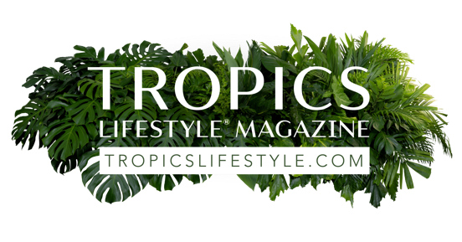

Rachel H. Kitt, Social Media Manager

Rachel Kitt is our social media manager and guru. She is in charge of communicating information about our Tropics Lifestyle organization, our partners and allied community members to the world. She is tuned into the inner workings of our [Tropics Lifestyle](https://magazine.tropicslifestyle.com/) digital magazine, [TropicsLifestyle.com](https://www.tropicslifestyle.com/) website, [Tropics Lifestyle Podcast](https://www.tropicslifestylepodcast.com/), Tropics Lifestyle Designer Directory, and other products produced by Palm Life Publishing LLC.

Rachel’s job also entails discovering highly interesting stories and tips that can help our audiences enjoy the tropics lifestyle influenced by beach, ocean and rainforest no matter where they live. That’s why she is always open to suggestions from our readers (and listeners) about what topics to cover in her social media posts on [LinkedIn](https://www.linkedin.com/company/tropicslifestylemagazine/?viewAsMember=true) (over 990 followers), [Facebook](https://www.facebook.com/TropicsLifestyleMagazine), [Instagram](https://www.instagram.com/tropicslifestylemagazine/) and [Tiktok](https://www.tiktok.com/@tropicslifestyle).

To share questions or comments with Rachel, please email her at [info@tropicslifestyle.com](mailto:info@tropicslifestyle.com?subject=*%20question%20or%20comment%20for%20Rachel%20Kitt,%20Tropics%20Lifestyle's%20social%20media%20manager)

Here are our Tropics Lifestyle social media links; find and follow us!

LinkedIn

Facebook

[Instagram](https://www.instagram.com/tropicslifestylemagazine/)

[Tiktok](https://www.tiktok.com/@tropicslifestyle)